Requirement Analysis

Data Flow Diagrams and User Stories
- Introduction
The Data Flow Diagram (DFD) represents the movement of data between users, system processes, and the database within the SHOPEZ E-Commerce Application. It provides a visual representation of how information is processed and stored throughout the application. User Stories describe the functional requirements from the perspective of end users and help define the expected behavior of the system.
- User Stories
US-1: User Registration
As a new customer, I want to create an account so that I can access the features of the SHOPEZ application.

US-2: User Login
As a registered customer, I want to log in securely so that I can access my account and place orders.

US-3: Browse Products
As a customer, I want to view available products so that I can select items for purchase.

US-4: View Product Details
As a customer, I want to view detailed information about a product so that I can make informed purchasing decisions.

US-5: Manage Shopping Cart
As a customer, I want to add and manage products in my shopping cart so that I can prepare my order before checkout.

US-6: Checkout
As a customer, I want to proceed to checkout so that I can confirm my purchase.

US-7: View Orders
As a customer, I want to view my order history and status so that I can track my purchases.

US-8: Admin Dashboard
As an administrator, I want to access the dashboard so that I can manage application data and monitor system activities.

- DFD Level 0
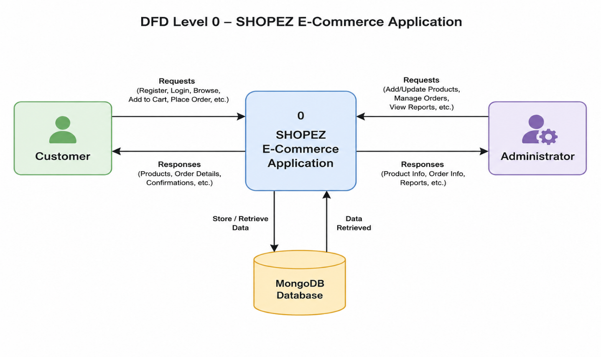
- DFD Level 1
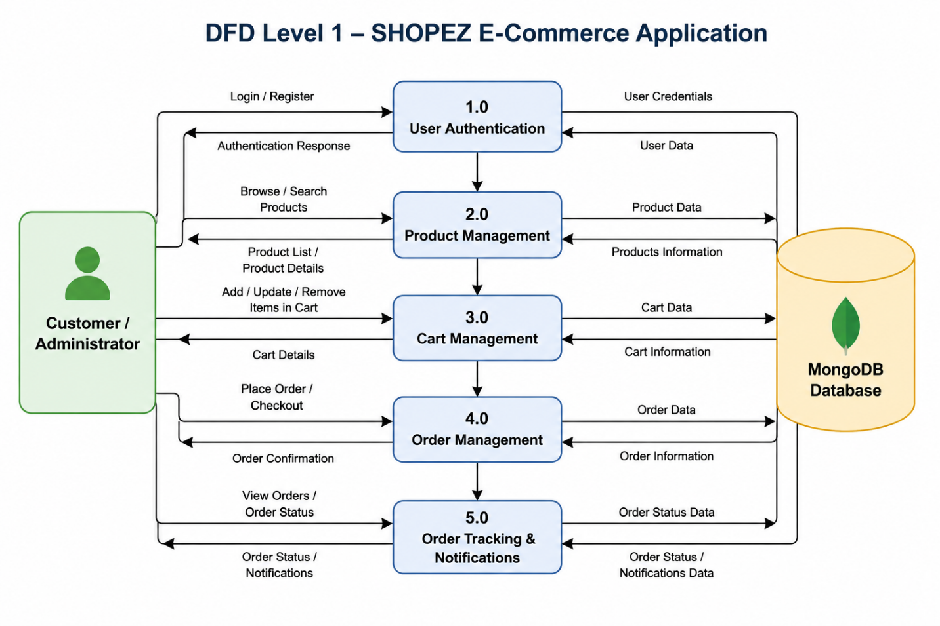
- Conclusion
The Data Flow Diagrams illustrate how data moves through the SHOPEZ E-Commerce Application, while the User Stories define the system requirements from the user's perspective. Together, they provide a clear understanding of the application's functionality and user interactions, serving as a foundation for system design and development.

